About the project

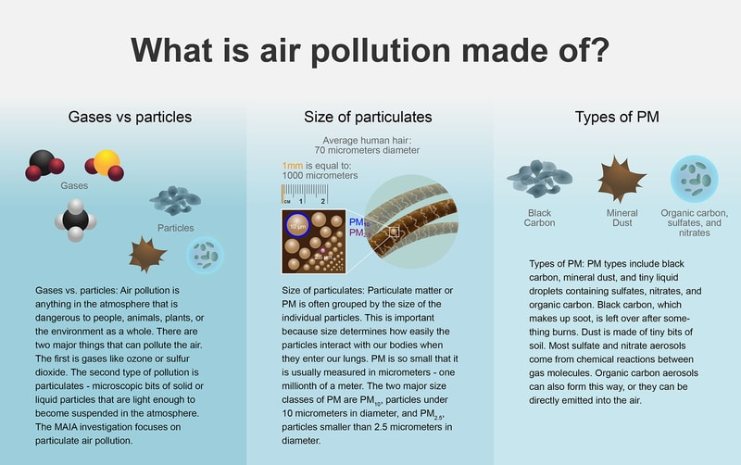

Air pollution includes gases (e.g., measures of NO2) and particles (e.g., measures of PM2.5). Source: [NASA JPL](https://maia.jpl.nasa.gov/your-health/#pollution/)

In order to take effective action against the ill health-effects of air pollution, the public needs air quality data that is low-latency (daily), high-resolution, and has widespread coverage. No single existing or in-formulation NASA satellite instrument provides ready-to-use data products on important surface-level air pollutants that meet these requirements. This gap in information means that millions of people cannot take action daily to protect their health.

Retrieval algorithms, which combine the available satellite data with ground-based monitor measurements, model outputs, and other data, appear to be the best route to provide local, daily air quality information at the surface-level in situations where traditional, but expensive, regulatory-grade ground monitors alone are not sufficient.

The science of using satellite data to study the health effects of trace gas and particulate pollutants is relatively new, rapidly evolving, and often relies on integration of satellite data with ground-based monitor measurements, atmospheric models, and a host of ancillary datasets. Many studies have been published in recent years describing such algorithms, but the science is not yet settled on what data inputs or what model types produce the highest performance. By contrast, public crowdsourcing can provide head-to-head comparisons of the best- performing NO2 and PM2.5 algorithms, which can aid in the dissemination of more accurate and value-added data products to the public.

This project is seeking the development of algorithms specifically focused on NO2 and PM2.5 that combine existing NASA satellite data, model outputs, and ground measurements to disseminate valuable air quality data to the user community, while advancing the state of the science for future NASA projects, including MAIA, TEMPO, and the [Atmosphere Observing System (AOS)](https://aos.gsfc.nasa.gov/home.htm) mission identified by the most recent Earth Science Decadal Survey.

NASA is working with representatives of the State Department and the Environmental Protection Agency (EPA) on this project. Successful results will potentially be used by the State Department at designated embassy locations providing useful information to their employees as well as the general public in those locations.

About Our Partners

This competition was created in partnership with teams at NASA, the National Aeronautics and Space Administration.

**NASA JPL (MAIA):** Currently in development, the [MAIA (Multi-Angle Imager for Aerosols)](https://maia.jpl.nasa.gov/) instrument will make radiometric and polarimetric measurements needed to characterize the sizes, compositions and quantities of particulate matter in air pollution. As part of the MAIA investigation, researchers will combine MAIA measurements with population health records to better understand the connections between aerosol pollutants and health problems such as adverse birth outcomes, cardiovascular and respiratory diseases, and premature deaths.

The MAIA instrument is being developed by the Jet Propulsion Laboratory (JPL), California Institute of Technology under a contract with the National Aeronautics and Space Administration (NASA). MAIA represents the first time NASA has partnered with epidemiologists and health organizations on a satellite mission to study human health and improve lives.

**NASA (TEMPO):** The [TEMPO (Tropospheric Emissions: Monitoring of Pollution)](http://tempo.si.edu/index.html) mission aims to answer “What's in the air we breathe?” with more detail and precision than ever before, by creating a revolutionary new dataset of atmospheric chemistry measurements from space. TEMPO will be the first space-based instrument to monitor major air pollutants across the North American continent every hour during the daytime.

The instrument, an ultraviolet and visible spectrometer, was completed in 2019 and will hitch a ride in 2022 on a commercial satellite to a geostationary orbit (GEO) about 22,000 miles above Earth's equator. This vantage point will enable TEMPO to monitor daily variations in nitrogen dioxide, sulfur dioxide, and ozone, along with other key elements of air pollution from the Atlantic to the Pacific, and from Mexico City and the Yucatan Peninsula to the Canadian oil sands. The instrument will also resolve pollution levels at unprecedented spatial scales (around 10 square kilometers).

You can learn more here:

* [MAIA (Multi-Angle Imager for Aerosols)](https://maia.jpl.nasa.gov/)
* [TEMPO (Tropospheric Emissions: Monitoring of Pollution)](http://tempo.si.edu/index.html)
* [How do scientists measure air pollution exposure (NASA JPL)](https://maia.jpl.nasa.gov/your-health/#pollution)
* [NASA Applied Remote Sensing Training (ARSET) Health & Air Quality Trainings](https://appliedsciences.nasa.gov/what-we-do/capacity-building/arset/arset-health-air-quality-trainings)